* **Write a program to parse XML text, generate Web graph and compute topic specific page rank.**

**CODE:**

import csv

import requests

import xml.etree.ElementTree as ET

def loadRSS():

url = 'https://wwwnc.cdc.gov/travel/rss/notices.xml'

resp = requests.get(url)

with open('topnewsfeed.xml', 'wb') as f:

f.write(resp.content)

def parseXML(xmlfile):

tree = ET.parse(xmlfile)

root = tree.getroot()

newsitems = []

for item in root.findall('./channel/item'):

news = {}

for child in item:

if child.tag == '{http://search.yahoo.com/mrss/}content':

news['media'] = child.attrib['url']

else:

news[child.tag] = child.text.encode('utf8')

newsitems.append(news)

return newsitems

def savetoCSV(newsitems, filename):

fields = ['guid', 'title', 'pubDate', 'description', 'link', 'media']

with open(filename, 'w') as csvfile:

writer = csv.DictWriter(csvfile, fieldnames = fields)

writer.writeheader()

writer.writerows(newsitems)

def main():

loadRSS()

newsitems = parseXML('topnewsfeed.xml')

savetoCSV(newsitems, 'topnews.csv')

if __name__ == "__main__":

main()

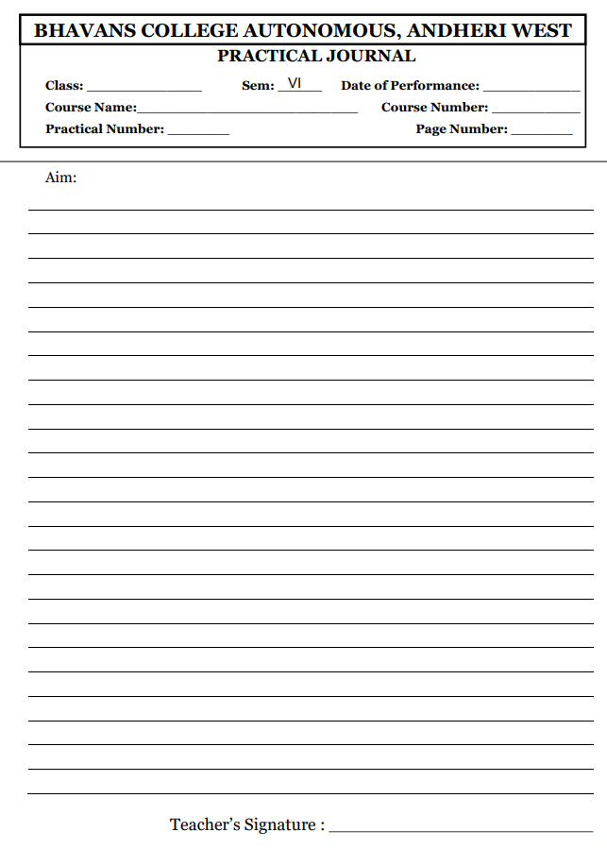

**OUTPUT:**



